Underwriting Multifamily

<https://www.meetup.com/Think-Multifamily-Real-Estate-Investing/events/262974267/>

**Attendees:** Mark Kenney, Justin Richards,

Minutes:

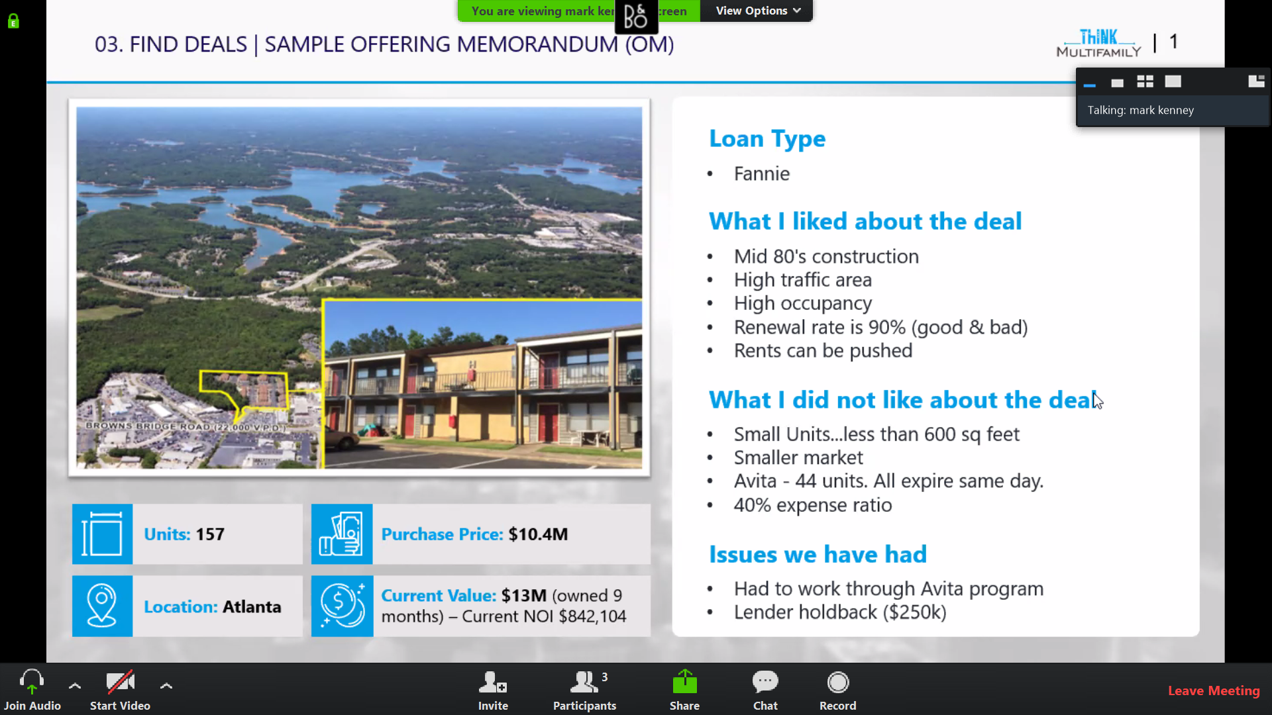

* Occupancy
  + >95% means not charging enough
* Renewal
  + >95% means not charging enough
    - Difficult to renovate – challenging when you have taken a loan
* Location: Gainsville, GA
* Avita:
  + Program – subsidized housing
* Expense ratio: 50% of income is general rule of thumb
  + Having 40% means their expenses are going to go up

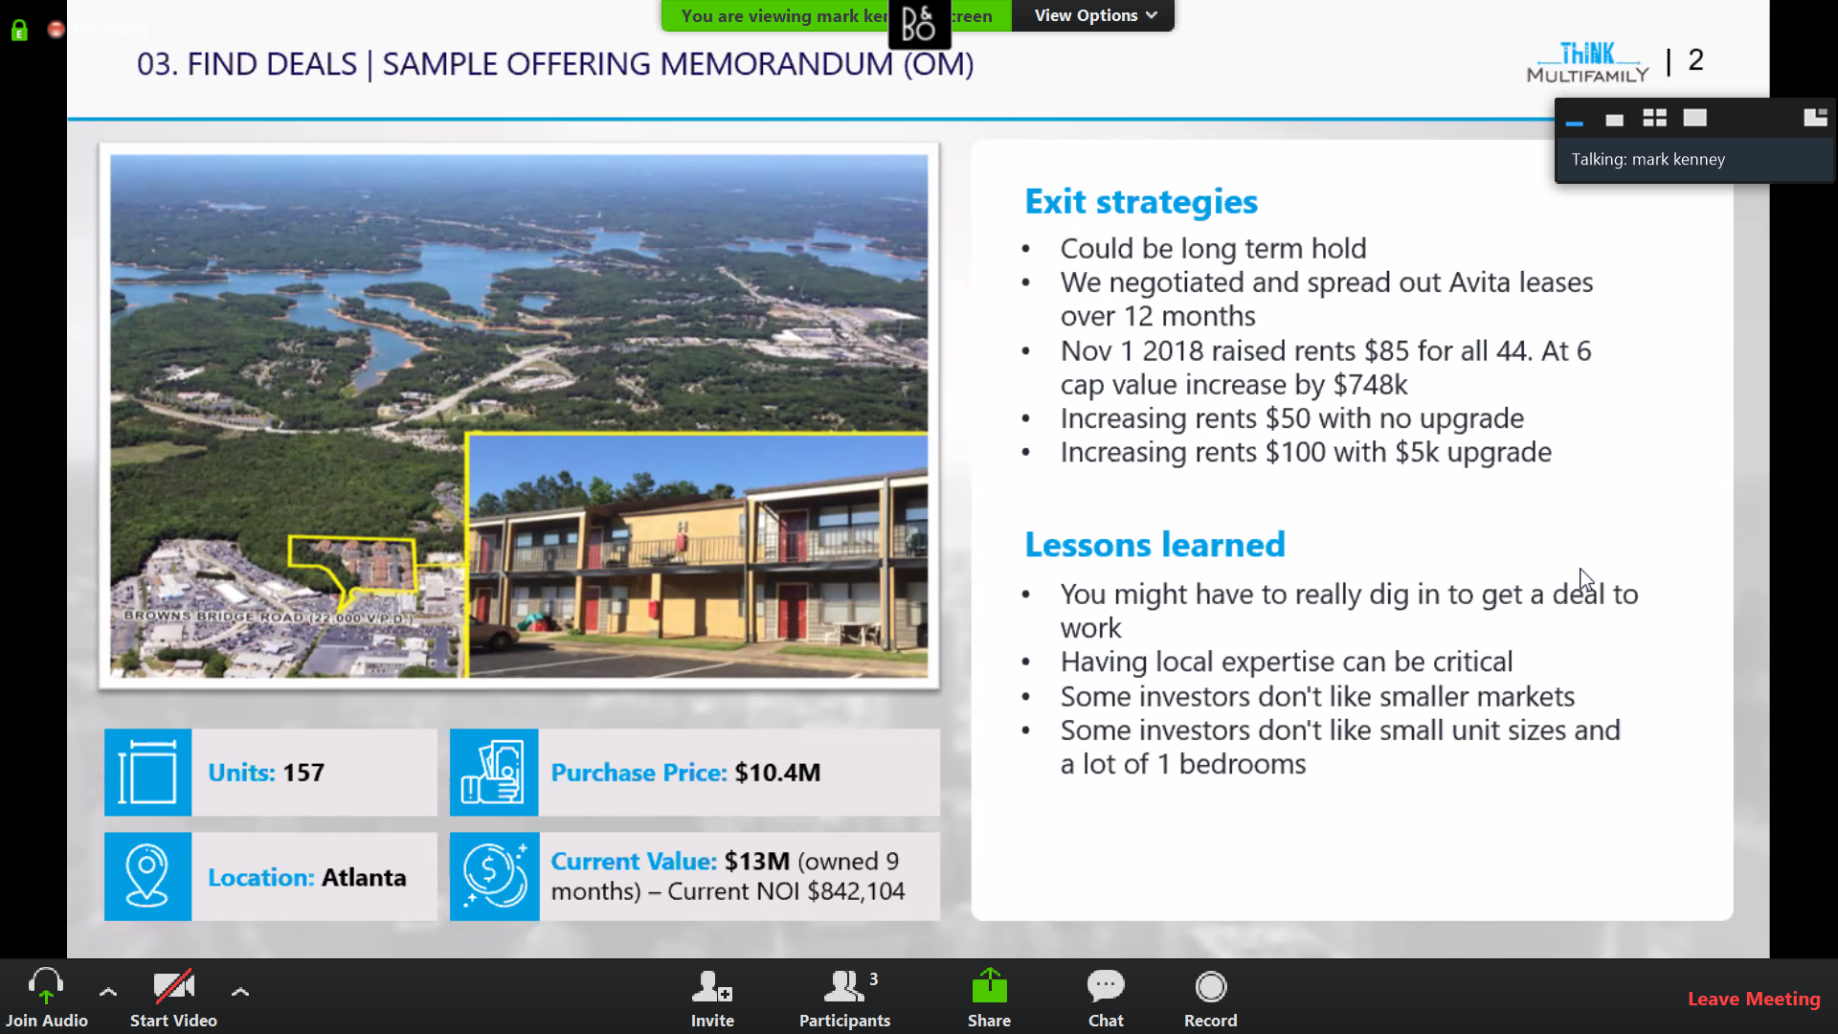

* For multifamily: Every $ increase in revenue results in $15 value up
* Questions
  + Did you have to do any upgrades/maintenance?
    - Rehab:
      * Engage a property management company or 3rd party to carry out due diligence and come up with an estimate
  + Where are you with the expense ratio? Still 40% (same payroll as 100 unit)
  + Non-recourse funding from lenders?
  + How did you go about securing larger scale lending (when starting)?
    - Using an experienced partner
  + CoC return? Higher return to attract investors for smaller location?
    - Total return > 100% in 5 years

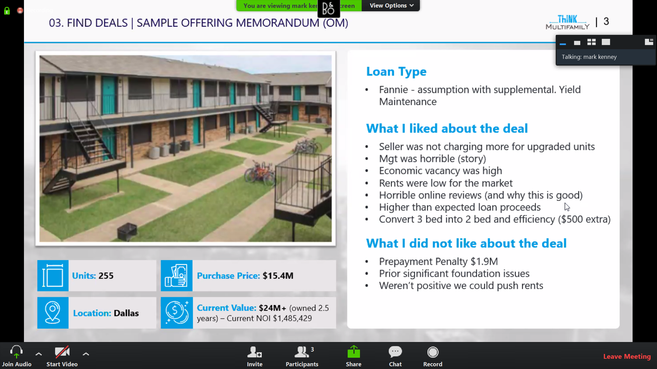

* Loan
  + Multifamily has a lot higher pre-pay penalties
    - In that case the buyer can take up (assume) seller’s loan
* Economic vacancy - includes
  + Physically vacancy
  + No pay
  + Concessions
  + Partial pay
* Foundation issues
  + Owner had repaired it
  + Warranty was transferrable

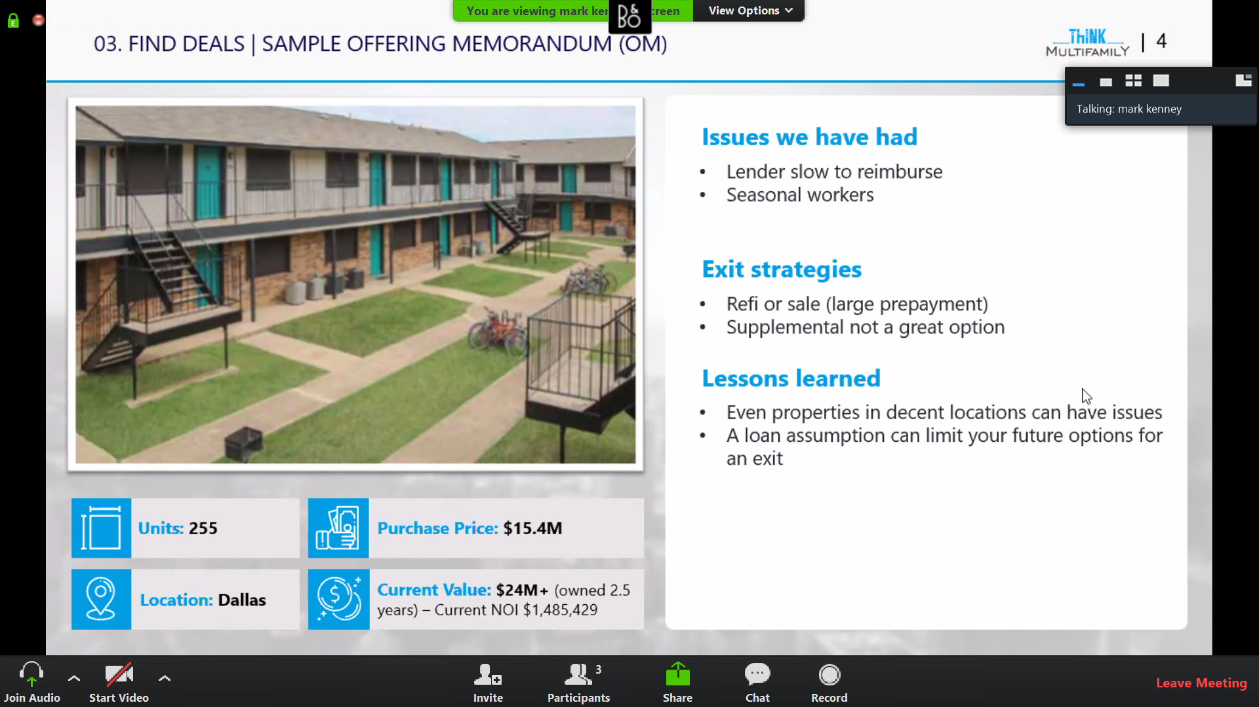

* Supplemental loan might not be a good option as you would need to take it from the same lender
* Loan assumption severely limits exit options
* Question:
  + Why 6 cap?
    - $90s a door
    - Cap rate – if you buy property on all cash, what will be your return
    - CDRA has website for CAP rate information
  + Why did you go in for loan assumption? Did that help you in negotiations?
    - Loan terms were good
      * Low rate of interest (<5%)
      * Had long enough on the loan (8 years)
    - Helped in the deal
  + Did investors question refinance decision?
    - Upfront in business plan
    - Lenders need 90% occupancy for last 3 months
    - Investors keep asking guestimates – do not guess
  + How do you pay yourself?
    - Acquisition fee (2%)
    - 8% preferred, 70:30
    - Asset management fee (1.5-2%)
    - Refinance – share refi proceeds with investors
  + Do you put money?
    - Yes
  + ThinkMulti-family -
    - A lot of syndicators take
      * Refi fee
      * Sell fee
      * 70:30 split

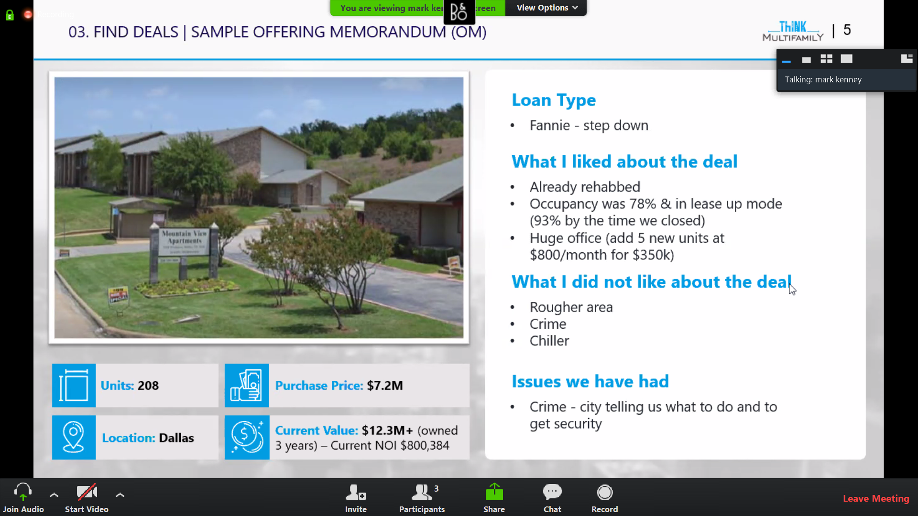

* Loan Step down
  + Prepayment penalty goes down
* Chiller
  + All units heated and cool from a single controller
* Getting security would costs around $100K per year

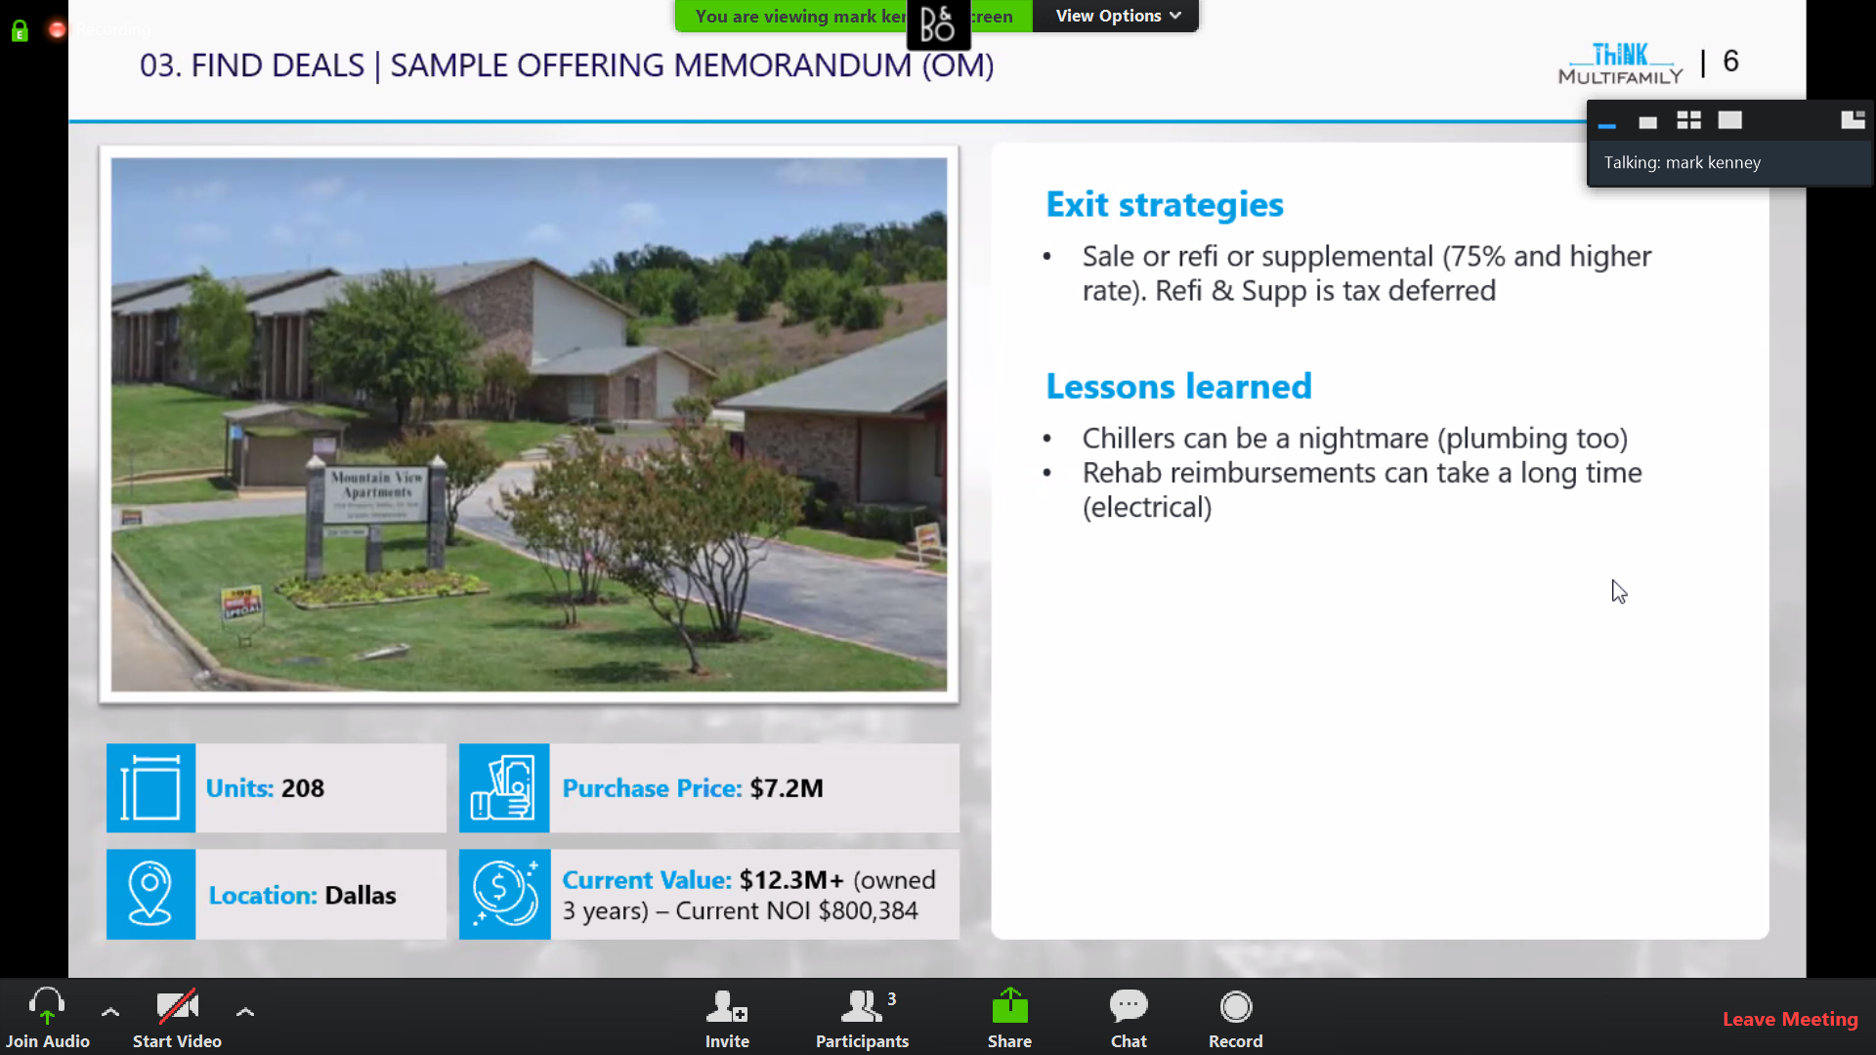

Questions:

* Why not change the chiller system?
  + Around $6K per unit
  + Going forward would underwrite chiller with a higher rehab costs (higher plumbing costs)
* Business plan for rehab?
  + % of the units instead of all
  + Helps in keeping operating expenses on
  + Consideration: any upgraded unit will have to be upgraded later
* Risk fee
  + Fee charged to lease to persons who do not qualify
* How is current value estimated?
  + NOI by caprate
  + BoV: Broker opinion of value
* Wiring issues?
  + If property has aluminum wiring, lender will require you to remediate it
  + Remediate
    - Ask lender to write it down what is required with details/rules
    - Engage an expert for their opinion on
    - Ensure lender is aligned with the remediation plan/details
* Bank issues & remediations?
* Underwriting – rent increase
  + 2% after stabilization
  + Expenses
    - Start @$5K per unit on capital costs can go either way
    - Normally no increase in expenses considered
* Property manager: rent ~$40K
* Buying out-of-state
  + For due-diligence
    - $25 - $45 per unit
    - Walkthrough of units
    - Lease order/review (physical)
    - Property manager: apartments.com has reviews
* To swipe a property manager
  + Terms on paper
  + Responsibility by the buyer
  + Local PM company is good
    - Local knowledge helps
    - Less costly
    - But also have less processes/bells & whistles
  + PM fees
    - 3.5 – 4% for a typical >100 units
    - Higher for lower # of units
  + Managing PM
    - Asset manager does that
      * Get financial reports, MMRs, Issues, etc.
      * Look for issues in the report
      * Communicating with investors
* Green Program (Fannie/Freddie)
  + You can get additional reduction in rate, by making upgrades that can reduce energy and resource consumption (water)
  + May not always work well, as utility is paid by tenants
* Turnover time
  + Vary from 1-2 weeks (carpet and painting) to market driven and what work you need to do

Programs & Tools

* 2 deal analysis class in Dallas
* Coaching: 1:1 coaching
* Blueprint available
  + Videos
  + Finding deals
  + Quick and dirty analyzers
  + Property tour application – bunch of questions to ask
  + Detailed analyzer